An Introduction to phylogeny constructions

Introduction: basic workflow
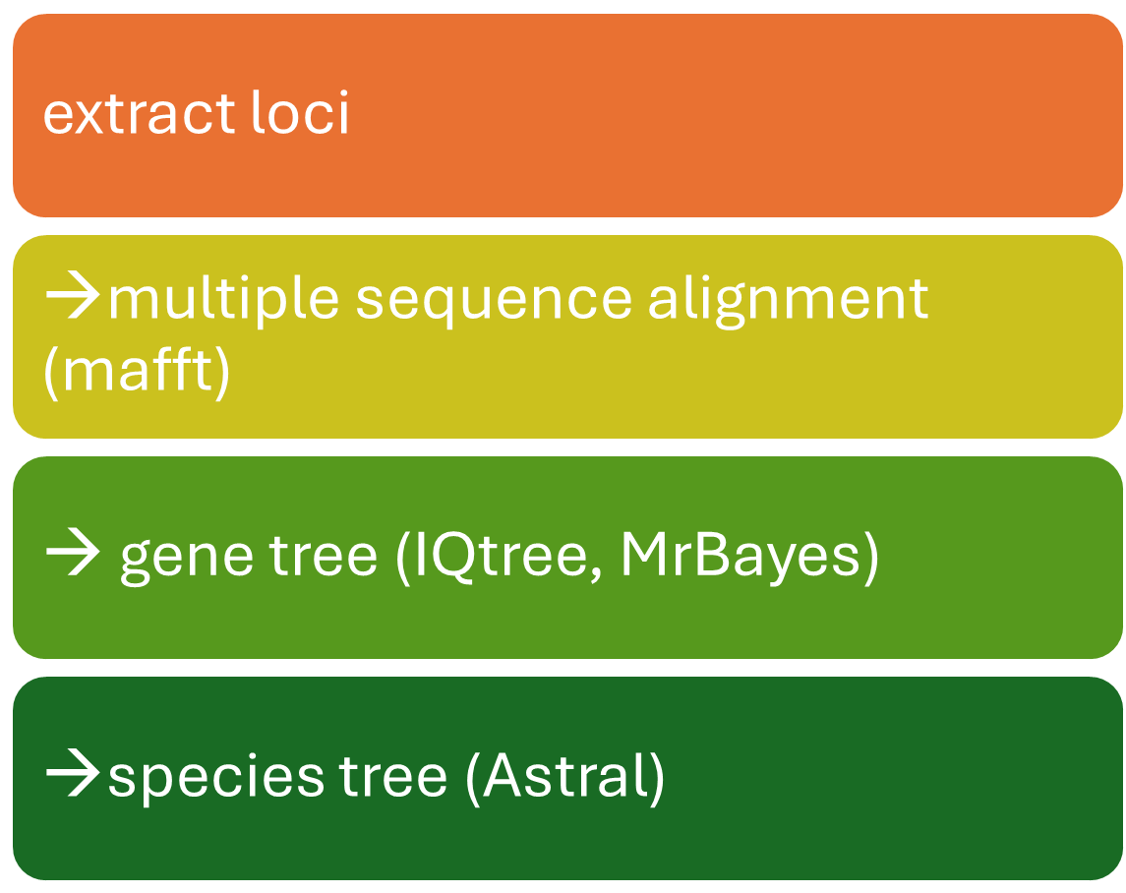

function setup_env {

conda create --name plastome_assembly -y
conda install -c bioconda getorganelle --name plastome_assembly -y
conda install -c bioconda seqkit --name plastome_assembly -y
conda install -c bioconda iqtree --name plastome_assembly -y
conda install -c bioconda mafft --name plastome_assembly -y
conda install -c bioconda blast --name plastome_assembly -y
}

OK if you just need the code for multiple sequence alignment and IQTree, this is it.

Plastome assembly

Initiate the database
https://github.com/Kinggerm/GetOrganelle
this one solves most of your issues. It’s using SPAdes asselmbler
from genomic skimming data. So WGS might be an overkill but it works still
download necessary databases
get_organelle_config.py --add embplant_pt,embplant_mt

If connection keeps failing, please manually download the latest database from GetOrganelleDB and initialization from local files.
The database will be located at ~/.GetOrganelle by default, which can be changed via the command line parameter --config-dir
It’s fine. This is a hidden directory, not doing any harm. Just let it be (keep default)

Get raw reads
We will follow the tutorial and download the reads for Arabidopsis:
wget https://github.com/Kinggerm/GetOrganelleGallery/raw/master/Test/reads/Arabidopsis_simulated.1.fq.gz
wget https://github.com/Kinggerm/GetOrganelleGallery/raw/master/Test/reads/Arabidopsis_simulated.2.fq.gz
then verify the integrity of downloaded files using md5sum:
md5sum Arabidopsis_simulated.*.fq.gz
# 935589bc609397f1bfc9c40f571f0f19 Arabidopsis_simulated.1.fq.gz
# d0f62eed78d2d2c6bed5f5aeaf4a2c11 Arabidopsis_simulated.2.fq.gz
# Please re-download the reads if your md5 values unmatched above

Fast Plastome assembly
(memory: ~600MB, CPU time: ~60s):
get_organelle_from_reads.py -1 Arabidopsis_simulated.1.fq.gz -2 Arabidopsis_simulated.2.fq.gz -o Arabidopsis_simulated.plastome -R 15 -k 21,45,65,85,105 -F embplant_pt -R 10
Understand the parameters:
- -1 FQ_FILE_1 Input file with forward paired-end reads (*.fq/.gz/.tar.gz).
- -2 FQ_FILE_2 Input file with reverse paired-end reads (*.fq/.gz/.tar.gz).
- -u UNPAIRED_FQ_FILES Input file(s) with unpaired (single-end) reads.
- -o OUTPUT_BASE
- -s SEED_FILE Input fasta format file as initial seed. Default: /home/zchen/.GetOrganelle/SeedDatabase/*.fasta
- -w WORD_SIZE Word size (W) for extension. Default: auto-estimated
- -R MAX_ROUNDS Maximum extension rounds (suggested: >=2). Default: 15 (embplant_pt)
- -F ORGANELLE_TYPE Target organelle genome type(s): embplant_pt/other_pt/embplant_mt/embplant_nr/animal_mt/fungus_mt/fungus_nr/anonym/embplant_pt,embplant_mt/other_pt,embplant_mt,fungus_mt
- --max-reads MAX_READS
    - Maximum number of reads to be used per file. Default: 1.5E7 (-F embplant_pt/embplant_nr/fungus_mt/fungus_nr); 7.5E7 (-F embplant_mt/other_pt/anonym); 3E8 (-F animal_mt)
- --fast FAST_STRATEGY ="-R 10 -t 4 -J 5 -M 7 --max-n-words 3E7 --larger-auto-ws --disentangle-time-limit 360"
- -k SPADES_KMER SPAdes kmer settings. Default: 21,55,85,115
- -t THREADS Maximum threads to use. Default: 1 (well doesn’t take much memory. It kinda depends on your genome size)
- -P PRE_GROUPED Pre-grouping value. Default: 200000
- -v, --version show program's version number and exit
- -h print brief introduction for frequently-used options.We can then work on something more interesting if this works

Seed file
A seed file is a FASTA file containing one or more known, related DNA sequences that serve as a "starting point" or "fishing hook" for the assembly process.
Think of it like this:
- Without a seed: You're trying to assemble a complete puzzle (the organelle genome) by dumping all the pieces (your sequencing reads) onto a table and trying to fit them together from scratch. This is slow and computationally intensive.
- With a seed: You start with a small, completed section of the puzzle (the seed sequence) that you know belongs to the final picture. You then only pick up puzzle pieces (reads) that look like they connect to this starting section, extending it outwards until the entire picture is complete.
For instance, when I am working with salix and potamogeton, I used known plastome assembly (fasta) from online database as seed files.
TBH the plastome is conserved enough that I can seed with salix plastome when assembling the Arabidopsis plastome.
Try with and without the -s option. The assembly will run slightly faster with seed file.

Output interpretation
Well, if everything goes right we will end up with one or two fasta files in the output directory:
ls *fasta
you might wonder how similar they are, and we can easily check using blastn:
makeblastdb -in embplant_pt.K105.complete.graph1.1.path_sequence.fasta -dbtype nucl -out graph1
blastn -db graph1 -query embplant_pt.K105.complete.graph1.2.path_sequence.fasta -outfmt 0 -soft_masking true > blast_1-2.txt
evaluate_assembly_using_mapping.py -f assembly.fasta -1 extended_1.fq -2 extended_2.fq -o output_dir -c yes --draw

it turns out the two fasta files are basically the same, which is not surprising and very convenient for our purpose. You only need to keep one.
And how different is it from our reference/seed file?
blastn -db graph1 -query …
you can also evaluate the read coverage of the assembly

Streamline the process for slurm
As an example, I am building a plastomid assembly database for the BGE project. We can make the jobs into an array to streamline the process

Assembly in array
(it seems giving more memory than 600G is necessary depending on the size of your read files…)
Often you can find the reference and baits from DToL or NCBI

function plastome_assembly {

REF=$1
INDIR=$2
OUTDIR=$3

#cleaning up
rm -rf ${OUTDIR}/${prefix}_${SLURM_ARRAY_TASK_ID}
get_organelle_from_reads.py -s $REF\
-1 ${INDIR}/${prefix}_${SLURM_ARRAY_TASK_ID}_R1.fq.gz \
-2 ${INDIR}/${prefix}_${SLURM_ARRAY_TASK_ID}_R2.fq.gz \
-o ${OUTDIR}/${prefix}_${SLURM_ARRAY_TASK_ID} \
-R 15 -k 21,45,65,85,105 \
-F embplant_pt
#get just one result
mv ${OUTDIR}/${prefix}_${SLURM_ARRAY_TASK_ID}/*graph1.1.*fasta ${OUTDIR}/${prefix}_${SLURM_ARRAY_TASK_ID}_pltm.fasta
rm -rf ${OUTDIR}/${prefix}_${SLURM_ARRAY_TASK_ID}
}
Quickly check the length of our assembly with seqkit stats: is it what you would expect?
file format type num_seqs sum_len min_len avg_len max_len
/mnt/shared/scratch/zchen/Barcoding_km/barcoding_combined_salix/Plastome/01_org_assembly/salix_10_pltm.fasta FASTA DNA 1 155,627 155,627 155,627 155,627
/mnt/shared/scratch/zchen/Barcoding_km/barcoding_combined_salix/Plastome/01_org_assembly/salix_11_pltm.fasta FASTA DNA 1 155,529 155,529 155,529 155,529
/mnt/shared/scratch/zchen/Barcoding_km/barcoding_combined_salix/Plastome/01_org_assembly/salix_13_pltm.fasta FASTA DNA 1 155,537 155,537 155,537 155,537
/mnt/shared/scratch/zchen/Barcoding_km/barcoding_combined_salix/Plastome/01_org_assembly/salix_14_pltm.fasta FASTA DNA 1 155,607 155,607 155,607 155,607
/mnt/shared/scratch/zchen/Barcoding_km/barcoding_combined_salix/Plastome/01_org_assembly/salix_15_pltm.fasta FASTA DNA 1 155,526 155,526 155,526 155,526
/mnt/shared/scratch/zchen/Barcoding_km/barcoding_combined_salix/Plastome/01_org_assembly/salix_18_pltm.fasta FASTA DNA 1 155,573 155,573 155,573 155,573
/mnt/shared/scratch/zchen/Barcoding_km/barcoding_combined_salix/Plastome/01_org_assembly/salix_19_pltm.fasta FASTA DNA 1 155,572 155,572 155,572 155,572
/mnt/shared/scratch/zchen/Barcoding_km/barcoding_combined_salix/Plastome/01_org_assembly/salix_1_pltm.fasta FASTA DNA 1 155,574 155,574 155,574 155,574
/mnt/shared/scratch/zchen/Barcoding_km/barcoding_combined_salix/Plastome/01_org_assembly/salix_20_pltm.fasta FASTA DNA 1 155,530 155,530 155,530 155,530
/mnt/shared/scratch/zchen/Barcoding_km/barcoding_combined_salix/Plastome/01_org_assembly/salix_21_pltm.fasta FASTA DNA 1 155,558 155,558 155,558 155,558
/mnt/shared/scratch/zchen/Barcoding_km/barcoding_combined_salix/Plastome/01_org_assembly/salix_24_pltm.fasta FASTA DNA 1 155,654 155,654 155,654 155,654
/mnt/shared/scratch/zchen/Barcoding_km/barcoding_combined_salix/Plastome/01_org_assembly/salix_3_pltm.fasta FASTA DNA 1 155,571 155,571 155,571 155,571
/mnt/shared/scratch/zchen/Barcoding_km/barcoding_combined_salix/Plastome/01_org_assembly/salix_4_pltm.fasta FASTA DNA 1 155,580 155,580 155,580 155,580
/mnt/shared/scratch/zchen/Barcoding_km/barcoding_combined_salix/Plastome/01_org_assembly/salix_5_pltm.fasta FASTA DNA 1 155,563 155,563 155,563 155,563
/mnt/shared/scratch/zchen/Barcoding_km/barcoding_combined_salix/Plastome/01_org_assembly/salix_6_pltm.fasta FASTA DNA 1 155,614 155,614 155,614 155,614
/mnt/shared/scratch/zchen/Barcoding_km/barcoding_combined_salix/Plastome/01_org_assembly/salix_7_pltm.fasta FASTA DNA 1 155,538 155,538 155,538 155,538
/mnt/shared/scratch/zchen/Barcoding_km/barcoding_combined_salix/Plastome/01_org_assembly/salix_8_pltm.fasta FASTA DNA 1 155,529 155,529 155,529 155,529

now we have assembled plastome from all samples, we are faced with another issue: how to align circular DNAs for subsequent phylogeny analysis

Scaffolding
Sometimes the assembly might not be complete. It will be indicated as multiple contigs appear in your assembly output file (seqkit stats)
For our purpose this time, we can simply ignore/remove those files, as most of the time we should be able to assemble the complete sequence.
But we can scaffold the contigs using a reference plastome.
This can be done easily with ragtag.
It is included in the script but I won’t go into details today.

Reorientation
First we need to anchor the sequence somehow. A convenient method is using rbcL
Find a good reference from NCBI and blast it against our plastome assembly:
cat ALL_THE_FASTA_FILES > MY_COMPILED_FILE.fasta
makeblastdb -in salix_compiled.fasta -dbtype nucl -out plstm
blastn -db plstm -query rbcl.purpurea.fasta -outfmt 6 -soft_masking true > blast_rbcL_plastome.txt
it tells us where the rbcL gene is in our plastome sequence. Well, it is roughly at the same position most of the times (~55k), but we do noticed a few sequences where taking reverse complement will be necessary (~151k) or simply not starting near the same area:
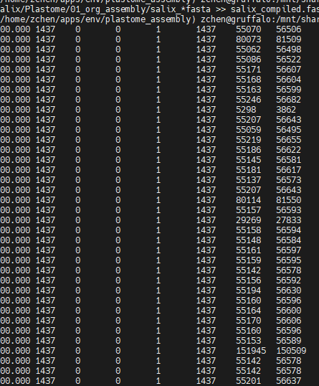
Fortunately we can manipulate the sequences easily with seqkit:
Seqkit restart: restart a circular sequence
Seqkit seq -p -v: take reverse complement (no biopython needed)
function reorient_sequences {

INDIR=$1
OUTDIR=$2

rm $OUTDIR/*fasta
#BLAST to find coordinate
cat $INDIR/*fasta > $OUTDIR/${prefix}_compiled.fasta
makeblastdb -in $OUTDIR/${prefix}_compiled.fasta -dbtype nucl -out plstm
blastn -db plstm -query $rbcl -outfmt 6 -soft_masking true > blast_1-2.txt
rm plstm* -f

while read l; do

name=$(echo $l|cut -f 2 -d ' ');
start=$(echo $l|cut -f 9 -d ' ');
end=$(echo $l|cut -f 10 -d ' ');
#echo $name $start $end

if [ $start -lt $end ]; then

#echo "pass"
seqkit restart $INDIR/${name}_pltm.fasta -i $start > $OUTDIR/${name}_pltm.fasta

else

echo 'reverse complement'
seqkit restart $INDIR/${name}_pltm.fasta -i $start |seqkit seq -p -r -t DNA > $OUTDIR/${name}_pltm.fasta

fi

done < blast_1-2.txt
}

Alignment + Phylogeny
It is also a good place to rename your plastome to a more meaningful sample names etc.
We can easily do alignment with mafft and infer the phylogeny using IQTREE
(it has a modelfinder so automatically picks the best substitution model)
The phylogeny can be visualized with figtree
Well it might look very wrong…
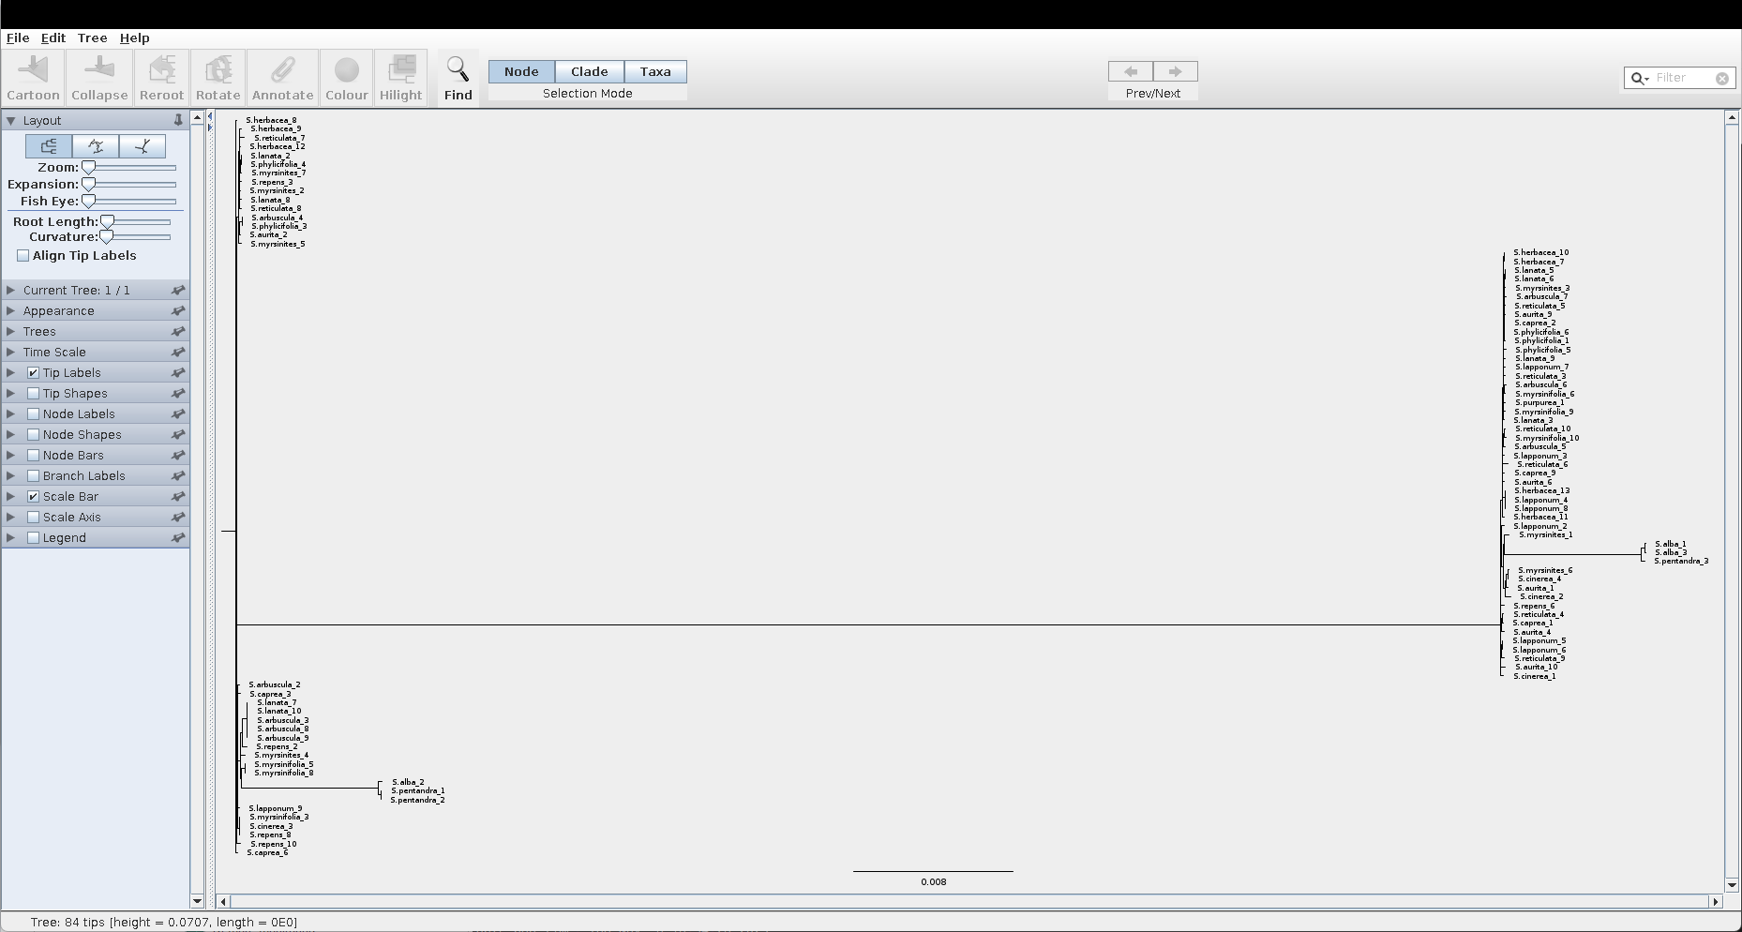
there is a misbehaving inversed repeat region in plastome genome. It would be a good idea to simply remove that bit after you’ve done the alignment.
The chloroplast genomes of most plants and algae contain a large inverted repeat (IR) region that separates two single-copy regions and harbours the ribosomal RNA operon.

https://doi.org/10.1038/s41477-024-01709-9: Removal of the large inverted repeat from the plastid genome reveals gene dosage effects and leads to increased genome copy number
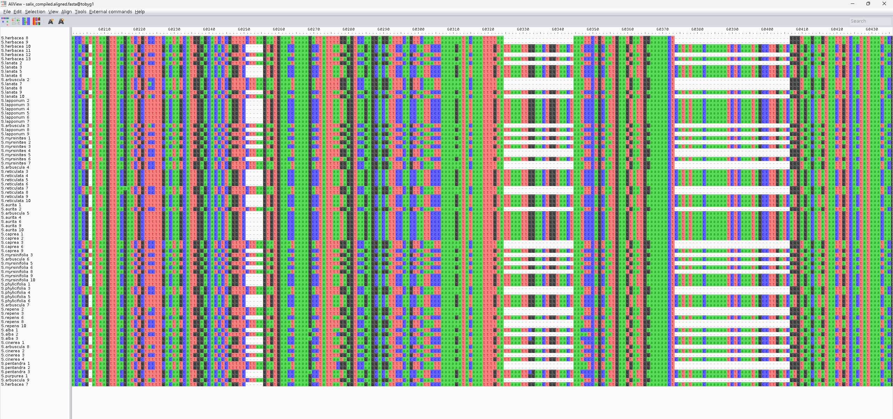
We can sort by selected columns in aliview, which makes things clearer.
After sorting, well apparently the samples randomly fall into two groups… and the region is not close to similar, as it is inverted repeats after all…
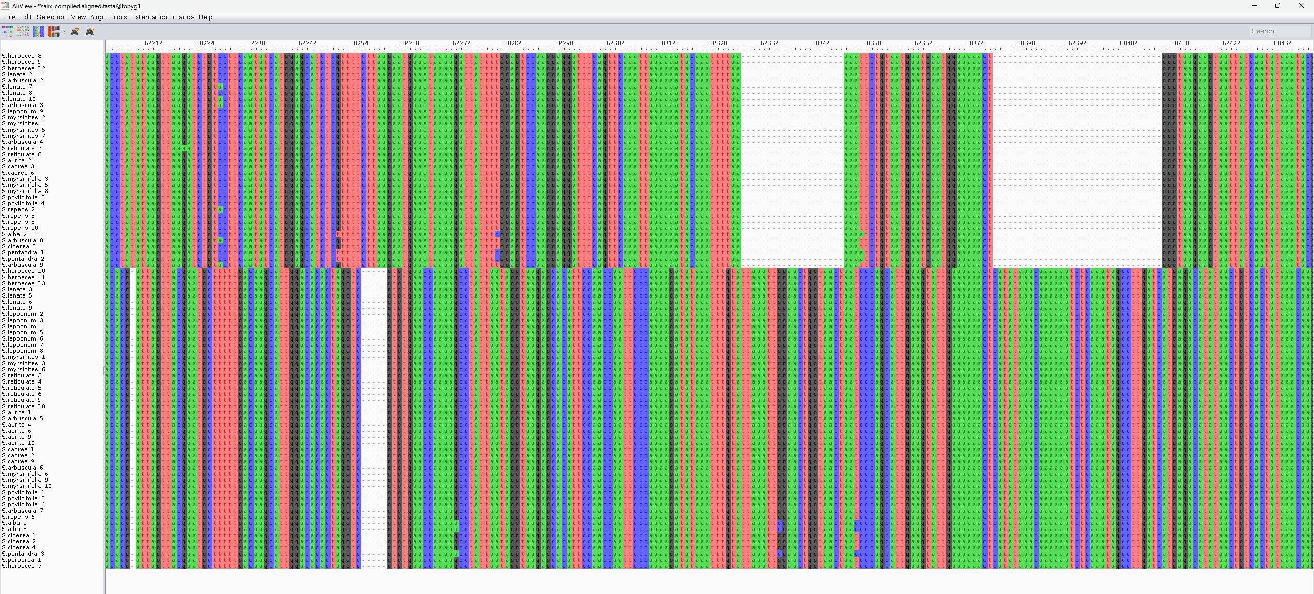
you can get rid of that region manually in aliview etc.
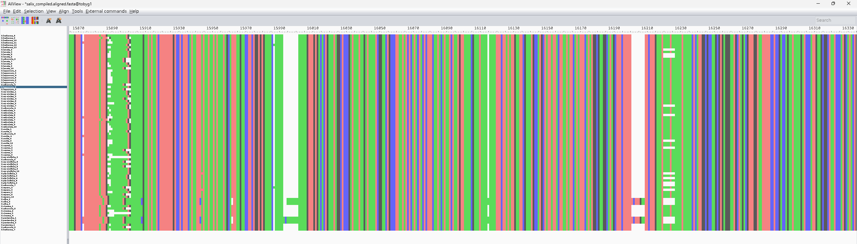
Then run iqtree again to get a new phylogeny tree:
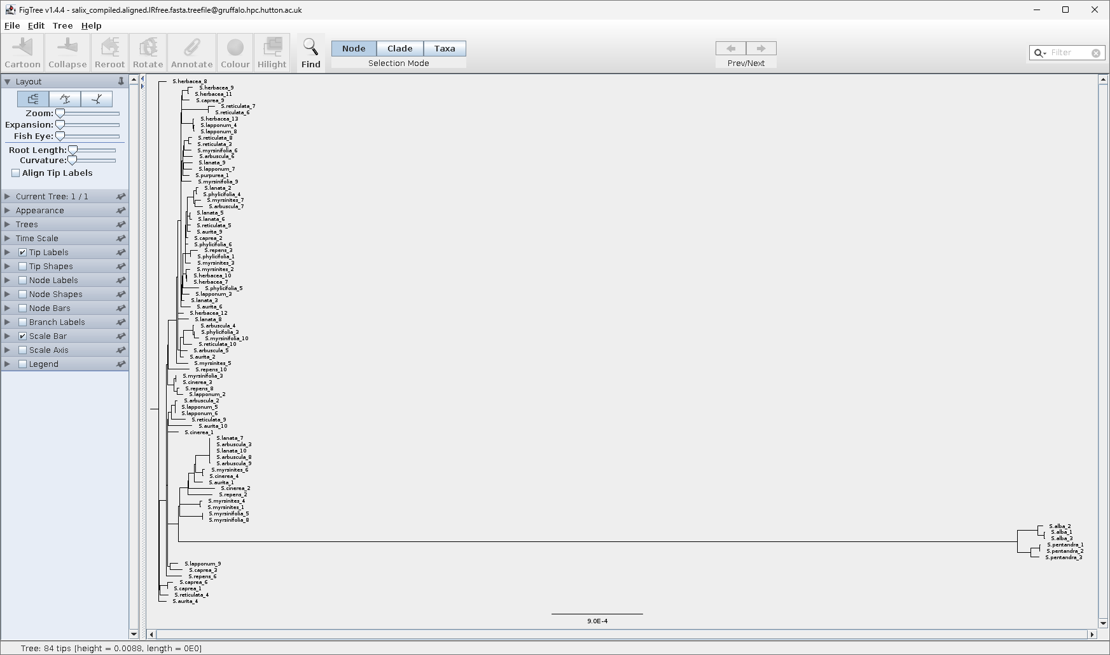
Much better...
But for some groups plastome simply cannot provide high enough resolution, including salix

Gene tree: IQTREE
A great tool for generating gene trees: IQtree
IQ-TREE (“Intelligent Quick Tree”) is a fast, versatile, and statistically rigorous program for phylogenetic inference using Maximum Likelihood (ML).
It is developed by Bui Quang Minh and colleagues and is now one of the most widely used tools for molecular phylogenetics and phylogenomics.
It’s the successor of PhyML and RAxML in many workflows — combining the speed of heuristics with advanced statistical features such as automatic model selection, ultrafast bootstrapping, and partitioned analysis.

- Automatic model selection
- Maximum likelihood
- Bootstrap support
- Computationally efficient
- Output treefiles compatible with ASTRAL for downstream species tree analysis

Core Algorithm and Functionality
a. Maximum Likelihood (ML) Tree Search
- IQ-TREE estimates the phylogeny that maximises the likelihood of observing the input sequence alignment under a specified model of evolution.
- It uses an efficient hill-climbing search:
  - Starts from an initial tree (e.g. via neighbour-joining or random trees).
  - Iteratively applies nearest-neighbour interchanges (NNI) and other topological rearrangements.
  - Retains changes that improve the log-likelihood until convergence.
- It’s optimised in C++ and uses stochastic perturbation to escape local optima — giving it an edge over older tools.
b. Site-Heterogeneous Models
IQ-TREE supports a very wide range of substitution models:
- Nucleotide: JC, HKY, GTR, etc.
- Amino acid: WAG, JTT, LG, etc.
- Codon models (e.g. MG94, GY94).
- Mixture models (e.g. LG4X, PMSF, C10–C60 profiles).
- Rate heterogeneity: Γ-distribution (+G), proportion of invariant sites (+I), or FreeRate models (+R).
These can be combined flexibly (e.g. GTR+F+R5).

ModelFinder: Automatic Model Selection
One of IQ-TREE’s most powerful features is ModelFinder, integrated directly into the workflow.
a. What it does:
ModelFinder tests a large set of candidate substitution models and selects the one that best fits the data according to an information criterion:
- AIC, AICc, BIC, or Corrected BIC (BICc).
It evaluates:
- Substitution matrices (e.g., GTR, HKY, etc.)
- Base or amino-acid frequencies (empirical vs estimated)
- Rate heterogeneity models (+I, +G, +R)
- Partition-specific models (if applicable)
b. ModelFinder+ (IQ-TREE 2)
Introduced in IQ-TREE 2, ModelFinder+ efficiently handles thousands of partitions and can test linked or unlinked models across genes.
c. Advantages
- Very fast (uses approximate likelihoods for initial ranking).
- Automatically suggests the best-fit model per partition or overall dataset.
- Can test mixture models and FreeRate models, often yielding better fits than traditional discrete Γ models.

Bootstrap and Branch Support Methods
IQ-TREE provides several advanced methods to measure branch support (statistical confidence in inferred splits):
a. Ultrafast Bootstrap Approximation (UFBoot)
- A fast approximation to traditional bootstrap resampling.
- 1000 ultrafast replicates can be computed in minutes rather than hours.
- Corrected versions (UFBoot2) reduce biases by including a bootstrap correlation test to detect model violations.
HAVEN’T USED THEM PERSONALLY BUT APPARENTLY AVAILABLE:
b. SH-aLRT (Shimodaira–Hasegawa approximate likelihood ratio test)
- Provides an alternative support measure based on local likelihood comparison among rearranged trees.
- Reported as SH-aLRT %, often combined with UFBoot support (e.g. “95/100”).
c. Transfer Bootstrap Expectation (TBE)
- A newer measure that is more stable for large trees and avoids overconfidence in deep branches.

Performance and Speed
IQ-TREE is extremely efficient due to:
- Stochastic tree search heuristics (jumping out of local optima).
- Multithreading and vectorised computations.
- Optimised numerical likelihood functions.
- Checkpointing for long runs and resuming interrupted analyses.
It generally runs faster than RAxML or PhyML while producing trees of equal or higher likelihood.

Output and Interpretation
Typical outputs include:
- .treefile – best ML tree with branch lengths and support.
- .log – log-likelihoods, model details, convergence.
- .iqtree – summary including model chosen, AIC/BIC scores.
- .ufboot – bootstrap trees.
- .model.gz – full list of models tested by ModelFinder.
Support values can be visualised in FigTree or iTOL, often as SH-aLRT / UFBoot pairs on branches.

Advantages (Pros)
Category | Advantages
Speed | Very fast tree inference and bootstrapping (UFBoot).
Accuracy | Statistically rigorous ML inference with mixture models.
Model Selection | Integrated ModelFinder gives data-driven model choice.
Flexibility | Handles DNA, protein, codon, and partitioned datasets.
Ease of use | Simple CLI syntax; clear logs and documentation.
Support metrics | SH-aLRT, UFBoot2, TBE, and concordance factors.
Parallelisation | Efficient use of multi-core CPUs.
Reproducibility | Stores seeds, parameters, and checkpoints.

Limitations (Cons)
Category | Limitation
Model dependency | As a model-based method, results can be biased if the wrong model is chosen.
ILS and hybridisation | ML assumes a single species tree (that’s why concatenation is not good often); does not account for incomplete lineage sorting or reticulation (use ASTRAL for that).
Gene tree error | For phylogenomics, separate gene tree estimation can introduce errors.
Memory use | Large genome-scale alignments may require high RAM.
Recombination | Assumes a single bifurcating history — not suitable for recombining sequences.

Phylogeny Visualization: FigTree
FigTree is a graphical viewer and editor for phylogenetic trees, developed by Andrew Rambaut (University of Edinburgh), who also co-developed BEAST.
It’s a lightweight (that’s why we can still use it in CropDiversity), Java-based program widely used for displaying, annotating, and exporting publication-quality phylogenetic trees.
FigTree doesn’t infer phylogenies itself — it visualises and manipulates tree files (usually in Newick or Nexus format) that are produced by programs like IQ-TREE, BEAST, MrBayes, or RAxML.

Main Purposes
- Visualise and edit phylogenetic trees.
- Display branch lengths, node support values, and annotations.
- Root, reroot, or reorient trees interactively.
- Change branch scaling and layout (rectangular, radial, polar).
- Export high-resolution figures for reports or publications.

Input and Output Formats
Input:
- Newick (.tre or .tree) — the simplest and most common tree format.
- Nexus (.nex) — often from BEAST, may include posterior probabilities, divergence times, or metadata.
Output:
- Vector and bitmap images: PDF, SVG, PNG, JPEG.
- Editable tree data: Nexus, Newick (after re-rooting or editing).

Tree Display Styles
FigTree offers multiple display modes, each emphasising different aspects of tree topology or branch length information.
Display Style | Description | When to use
Original Tree | Shows the tree exactly as inferred — branch lengths are proportional to the evolutionary distances (e.g., substitutions per site). | For ML or Bayesian trees where branch length conveys genetic divergence.
Equal (or "Ultrametric/Equal Branch Lengths") | All tips are equally distant from the root, regardless of branch length. | For visual clarity or when branch length information is unreliable.
Cladogram | Displays topology only — all branches have arbitrary length. | To emphasise relationships rather than distances.
Proportional | Branch lengths proportional to another attribute (e.g., time, number of substitutions, posterior support). | For time-calibrated trees (BEAST) or comparative visualisation.
Let’s unpack each transformation further.

Original Tree
- Uses actual branch lengths from the input file (e.g., expected number of substitutions per site).
- If the tree is ultrametric (as in BEAST), tip heights align automatically; if not, tips may end at different distances from the root.
- Best for showing evolutionary rates or distances.

Equal (Ultrametric)
- Forces all terminal taxa (tips) to align vertically.
- Ignores actual branch lengths and replaces them with equal distances.
- Useful when:
  - The inferred tree isn’t ultrametric but you want a clean visual comparison.
  - You want to highlight topology only, not rate variation.

Cladogram
- A simplified topological tree.
- Branch lengths are arbitrary, typically drawn to fit the display window.
- All internal nodes are positioned equally between the root and tips.
- Excellent for displaying only evolutionary relationships without any measure of distance.

Proportional
Well I found these info online but so far I haven’t found a way to change/figure out what proportion it is
- Scales branch lengths to a user-defined variable or annotation (e.g., divergence time, posterior mean, number of substitutions).
- FigTree can extract numerical annotations (often in BEAST .trees files, e.g. height, posterior, or rate) and visualise them by length or colour.
Example:
- Branch length ∝ “height_95%HPD” → time-calibrated confidence intervals.
- Branch thickness ∝ “posterior” → support proportional to visual width.

Tree Orientation and Layout Options
FigTree provides several layout orientations:
Layout | Description
Rectangular | Standard left-to-right (or top-down) layout; most common for publication figures.
Circular / Radial | Tree radiates from the centre — good for large trees.
Polar | Can be unrooted! Alternative to circular layout that emphasises divergence times.
Phylogram vs. Cladogram toggle | Switch between proportional and equal branch lengths.
You can also flip nodes or order descendants to control the arrangement of clades.

Ordering and Rerooting Nodes

(a) Ordering Nodes
You can reorder sister clades to make the tree visually clearer:
- Order nodes by:
  - Increasing or decreasing node age
  - Manual flipping (click and drag).
Reordering doesn’t change the topology; it only changes the visual layout.

(b) Rerooting
Rerooting allows you to define a new root:
- Click on a branch and select “Reroot”.
- Common for rooting an unrooted ML tree on an outgroup.
- Tip labels and branch lengths automatically adjust relative to the new root.

Scale and Axis Features
(a) Scale Bar
- Displays a scale bar showing the units of branch length.
- In ML trees: usually substitutions per site.
- In BEAST trees: time (e.g., millions of years) if calibrated.
- Can be rescaled manually for readability.
(b) Axis Display
- Option to show a time axis (for ultrametric trees) across the top or side.
- Useful for visualising divergence times and fossil calibrations.
(c) Log-scale or Custom Transformations
- For some datasets (e.g. molecular clocks with large variance), FigTree allows log-scaling of branch lengths to compress long branches.

Annotating Trees
FigTree supports various visual annotations:
Element | Description
Tip labels | Display or hide species names, format font, rotate, align.
Node labels | Display bootstrap values, posterior probabilities, or other annotations.
Branch labels | Display numeric data stored on branches (e.g. substitutions, rates).
Colour coding | Colour branches or labels based on categorical or numeric variables (e.g., clade, posterior).
Node shapes | Circles or bars representing metadata values (e.g., sample size, time).
Annotations can be extracted automatically from BEAST or IQ-TREE outputs (e.g., “support”, “posterior”, “rate”, “height”).

Exporting Figures
You can export publication-quality trees:
- Vector graphics: PDF, SVG (editable in Adobe Illustrator, Inkscape).
- Bitmap images: PNG, JPEG (for quick inclusion in slides).
- Transparent background option available.
- Control over font embedding, scaling, and resolution (DPI).

Strengths and Limitations
Strengths | Limitations
User-friendly GUI for non-programmers | No command-line mode (unsuitable for batch automation)
Supports most standard formats (Newick, Nexus) | Can struggle with very large trees (>10,000 taxa)
Flexible tree transformations (original, equal, proportional) | Limited editing of underlying data (can’t recalculate ML values)
Integrates well with BEAST and IQ-TREE outputs | Primarily designed for visualisation, not analysis
Publication-quality export options | Static (no 3D or interactive web visualisation)

